S-EYE User Manual

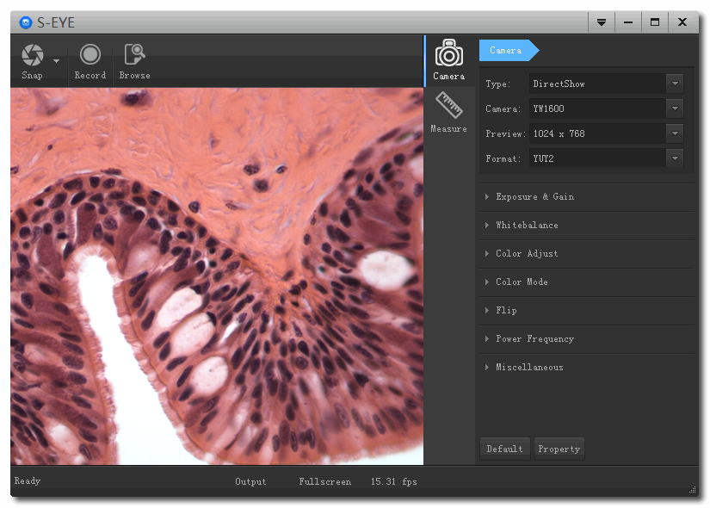

S-EYE V1.2

Overview
S-EYE is an application for imaging a dynamic image processing, has the following characteristics:
- Support a variety of cameras, can switch at any time to use.
- Using GPU rendering for image previewing, support for live image display of high-resolution and high frame rates.
- Support dynamic image measurement function.
- The software interface is easy to operate.

User Interface
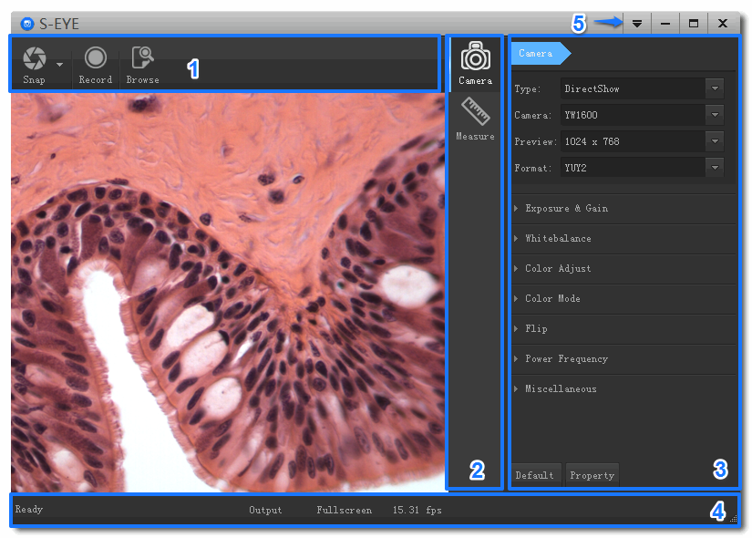

- Toolbar：Take pictures/Recording video/Browse files.
- Sidebar tab：Switching the rightmost control panels currently provides camera control and measurement functions.
- Control panel：Specific camera control and measurement operations.
- Status bar：Display camera information, Change user interface view, and Toggle measure result panel.
- Main menu：Open setting dialog, show software information, etc.

Capture Images
You can capture pictures and videos：
- Take a picture: Click “Snap” button to take a picture. Click the right arrow beside the “Snap” button to set picture file format and resolution.
- Recording：Click “Record” button to start video recording, Click again to stop recording. When recording, there will be an animation indicator over the image.
- Browse：Click “Browse” button to open the folder where pictures and video stored.

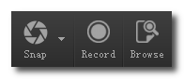

Camera Control
Screen shot | Description
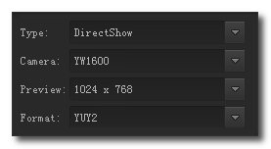 | Device Control:  - Select a camera currently connected.  - Set preview size and image format.
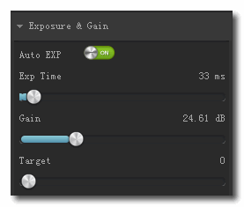 | Exposure and Gain:  - Toggle automatic and manual exposure control.  - Change exposure time.  - Change gain value.  - Change auto exposure target brightness.
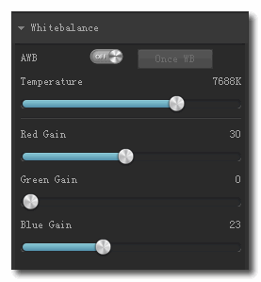 | White balance:  - Toggle automatic or manual white balance.  - One push white balance.  - Change color temperature.  - Change red/gain/blue gain value.
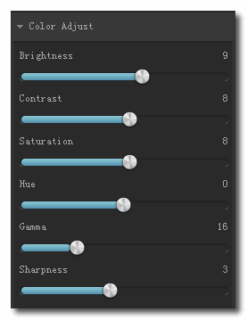 | Normal camera parameter adjustment.
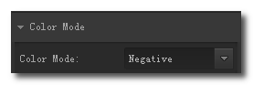 | Color mode
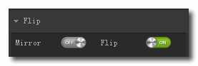 | Flip image vertically and horizontally.
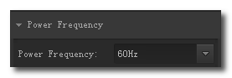 | Power frequency:  To avoid image flicker, you may need change this parameter.
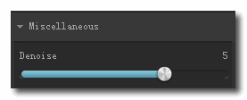 | Decrease the noise from the image.
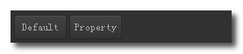 | - Reset camera parameters.  - Open camera property dialog if it existed.
*If the selected camera does not support some features, the corresponding interface controls will not be operated.

Measurement
ICON | FUNCTION | Description
 | Move | Move or adjust the measurement tool.
 | Point | Draw a marker over the image.
 | Line | Measure length of a line.
 | Break line | Measure length of break line, right click to finish drawing.
 | Rectangle | Measure perimeter and acreage of a rectangle.
 | Polygon | Measure perimeter and acreage of a polygon.
 | Circle | Measure a circle, the circle is determined by center point and radius.
 | Two Points Circle | Measure a circle, the circle is determined by two points.
 | Three Points Circle | Measure a circle, the circle is determined by three points.
 | Arc | Measure length of arc.
 | Angle | Measure angle.
 | Perpendicular | Measure the distance from a point to a line.
 | Delete | Delete one measurement tool.
 | Delete all | Delete all measurement tools.
 | Export | Export measurement result to file.

Troubleshooting
Problem | Solution
Some parts of the preview image are blank, some parts are normal. | Possibly the graphics drivers may not be installed, please install the latest graphics drivers.

